AGRESSO GUIDE
REQUISITION ENTRY NOTES

Contents
Requisition Approval Process 2
Raising a Requisition 3
Apply a Discount to a Requisition 5
Parking a Requisition 6
Closing a Requisition 7
To view/amend an existing Requisition 8
Tax Clearance Cert has expired 8
Error messages 9
Requisitions Reports 9
- Requisitions in Workflow 10
- My Requisitions 10
- All Requisitions 10
- Parked Requisitions 10

Requisition Approval Process

- User raises a requisition which must have a valid quote attached.

- Budget Holder Approves Requisition

- Finance Check – To review quote/back up and coding

- Finance Approval – To

- Approved Requisition is converted to a Purchase Order.
Supplier will receive a system generated email with the PO Number
The Requisitioner (you) will receive an email to advise of the PO number.
This is the number to be used on invoices for payment (the requisition number is not accepted)

- The Supplier emails their Invoice to AccountsPayable@tus.ie ensuring the TUS Purchase Order Number is quoted on the invoice.

- The Invoice is registered by a member of the Accounts Payable Team and goes to workflow for approval,

Raising a Requisition
There are two tabs that need to be completed.

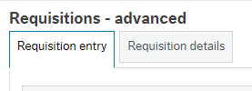

First Tab – Requisition Entry

- Enter supplier. You can type the first characters of any word in the name or the account number to see a list of possible values.
- No entry required in the Contact Field
- Enter the Subacc (Dept/Project Code) e.g. A705 - PF00111
- Ensure the delivery address is correct. You can change it using the drop-down list in the Delivery Contact box.
- Delivery attention – enter your email address or who the Supplier should contact with any queries

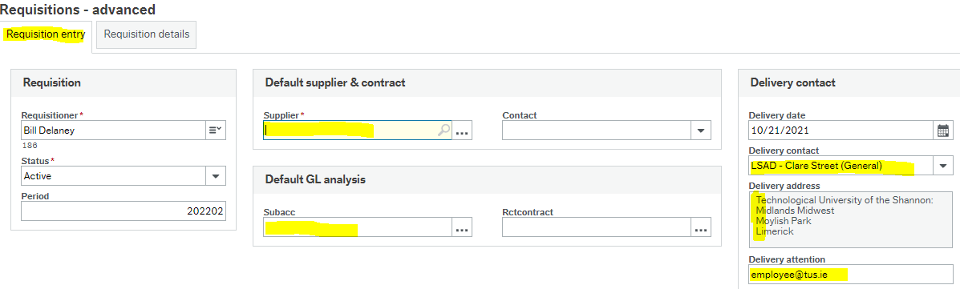

Second tab – Requisition Details
- Click on product, type G (goods) or S (service).
Note: there should not be a mix of G type and S type on a requisition. If Goods will be delivered, all lines should be G type. If there will be no delivery, all lines should be S type.
- Enter Description of item being ordered. Include product code if provided on the quote.
- Enter quantity (for Goods only)
- Check the currency is correct and matches the currency on the quote.
- Enter the price in the currency of the quote.

- Scroll down to GL Analysis. Enter the Account code (nominal code) e.g. 3000 class materials.
- Subacc will be linked in from the first tab, but can be amended if required.
- Other fields may be required depending on the GL code selected. There will be a drop-down list of values for all new codes. If you are unsure, please contact Finance.
ProjCode: To be entered where certain specialist funding is used e.g. TUTF, Devolved Grant, Covid Support, etc. Please contact Finance for details.

- Tax Code – the VAT rate. Usually starts with a P (Irish Suppliers), F (Foreign EU Suppliers) or Y (Other Foreign Suppliers).
P0 – F0 – Y0 = 0%
P1 – F1 – Y1 = 13.5%
P2 – F2 – Y2 = 23%
P9 – F9 – Y9 = 9%

Click on the Knowly Icon to view additional detail on Tax Codes

- Tax System – Default entry – Do not amend
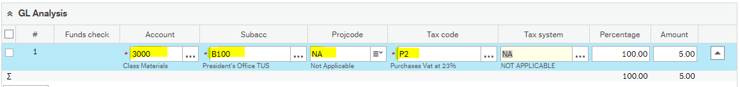

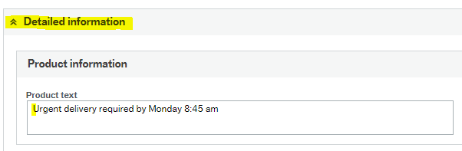
- To add additional information, choose Detailed Information & enter detail in the product text box.
- Enter Quote number
- Enter Order confirmation number for online orders
- Enter names for courses, training, field trips, accommodation, flights…
The information will be printed just below line on the PO.

- To add another line, go back up to the next blank line in the Requisition Details section and click in the product box

- Scroll down to the GL Analysis once you have added a new line, you will need to complete details for this new line (Account, VAT etc, the same as steps 11-15). This must be done for all additional lines. If you get the below error message it may be that the GL Analysis is not completed in on one (or more) of the lines.
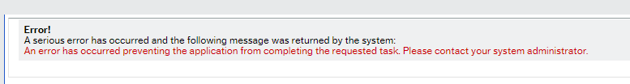


Before you save the Requisition, you need to attach any relevant quote/quotes. To attach a quote, click the paperclip symbol on the top right corner. Choose requisition quotation and add new document. Click upload to browse your PC. Select the document and choose upload, save and x the box. If you do not attach the quote, the requisition will be automatically rejected and sent back to you for amendment.

When you save the requisition, you will be asked to select the requisition type once again.
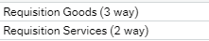

Click the OK button. You should see a pop-up box with your Requisition number.

Apply a Discount to a Requisition

Open Detailed information
Enter the Discount percent for each line of the requisition
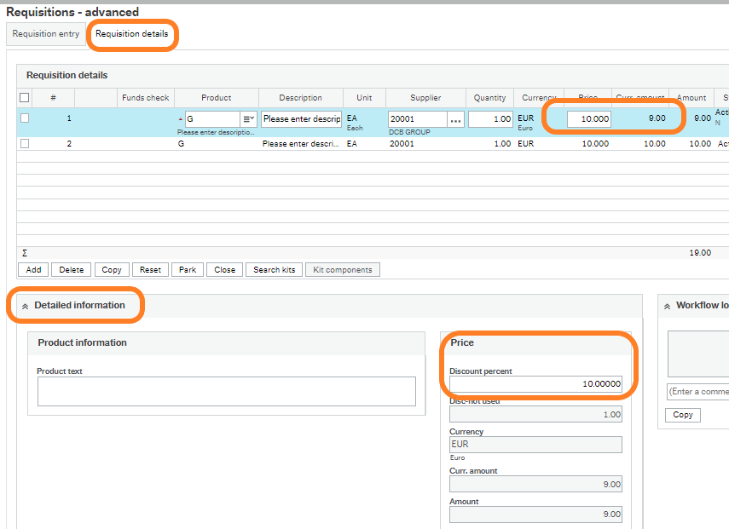

Parking a Requisition

Initially, the order status will be set as “Active”. To save a Requisition which is incomplete or where funds are not available the status should be set to Parked. Parked orders will not progress through workflow.
To change the status to parked, go to the Requisition Entry tab and change the Status to ‘Parked’ and Save.
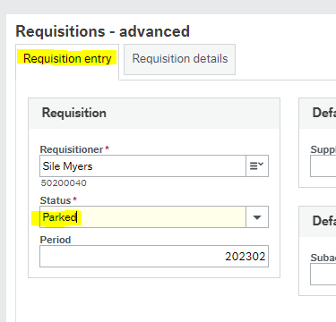
The Requisition will need to be Unparked and set to Active in order to progress through Workflow

Closing a Requisition
Amend the Status to Closed and select Save
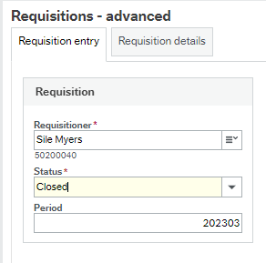
To Close an individual line on a Requisition which has already been Saved – Select the line and Click on Close.
Note Status on Line 2 is set to Closed.
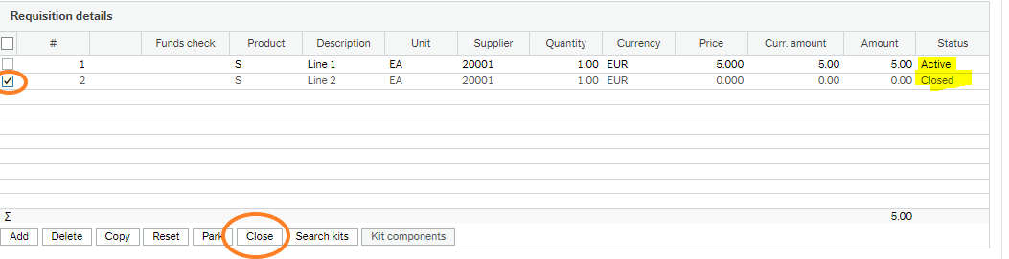

To view/amend an existing Requisition
From the Requisitions Advanced Screen (same as when raising a Req).
Click open, Close the pop up box, enter the requisition number in the Requisition Number field.
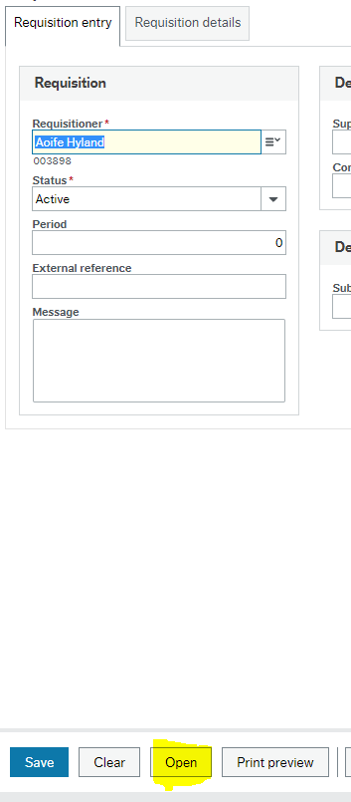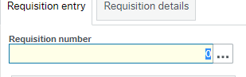
Requisitions can only be amended if still in the workflow process. Requisitions that have been fully approved and a PO generated cannot be amended.

Tax Clearance Cert has expired

If you receive a Tax Clearance Cert (TCC) error message upon saving a Requisitions please contact purchasing@tus.ie with the supplier details.
Your Requisition will be set to a status of Parked until a member of the Accounts Payable Team updates the Supplier to confirm Tax Clearance and also unparks the Requisition.

Error messages

- If you see the following error message, the system has timed out. You will need to close the application and re-open it.

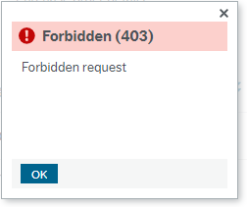

- If you see the following error message, you need to log out of the system. Log out by selecting the arrow beside your username.

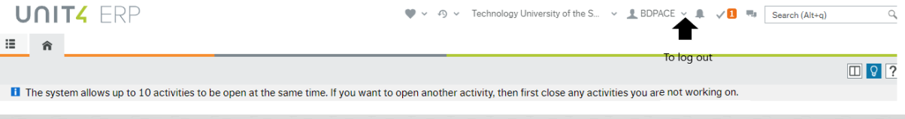

Requisitions Reports

- Requisitions in Workflow
Shows Requisitions still in the Workflow process and with whom the Requisition is currently with (Task Owner)
If your Requisition does not appear in this Report, it is either fully approved or Parked.
Enter a Requisition Number and click Search or just click Search to show all Requisitions currently in Workflow

My Requisitions
Search for a particular Requisition or Purchase Order Number here.
Clicking on the Purchase Order will bring you to the Purchase Order screen where you can download a copy of the Purchase Order by clicking on the paper clip icon.

All Requisitions
Shows all Requisitions raised within the Department you have access to.
As above Clicking on the Purchase Order will bring you to the Purchase Order screen where you can download a copy of the Purchase Order by clicking on the paper clip icon. You can also view the coding of the PO in the GL analysis section of the PO.
- Parked Requisitions
Requisitions Parked by you the User or due to an issue with Tax Clearance.

