AGRESSO GUIDE
REPORTS FOR REQUISITIONERS

Contents
Introduction to Web Reports 2
Budgets Annual 2
Budget Multi Year 3
PO/Req Enquiry 3
Transaction Listings 4
Invoices Paid 5
Supplier Look up 6
Additional Reports 7
Exporting Reports 7
Queries 7

Introduction to Web Reports

Reports are available
within the Requisitioner Workspace
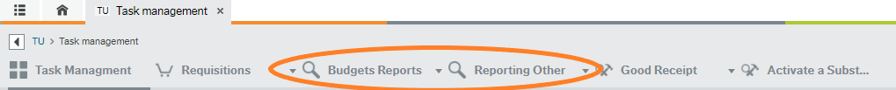
Reports will require input from the user. ie Subacc
Once a report has run, you can use the filter options. These are the blank fields above the generated report. Once you have entered your filter options ie. a particular Dept/Subacc hit search and the report will filter accordingly.
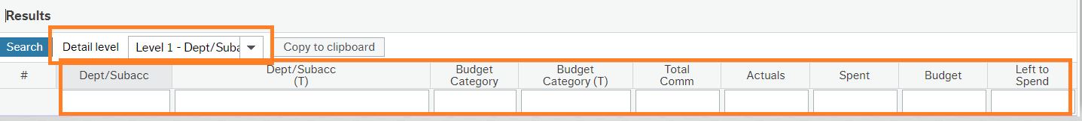

You can expand the report further by changing the detail level to Level 2 Budget Category or All Levels

Budgets Annual
This report will show the budget and activity for your assigned Subacc/Dept for the current academic year. It is the main budget report for viewing Faculty/Department budgets

As outlined in the running reports section above you can filter these results using the report headings and the dropdown under the detail level.

If you are viewing the report in all levels, you can drill into amounts to find further detail and view any attached documentation.

Annual Budgets are released in 3 Tranches over the course of the Academic Year:
Tranche 1 - Sept - Dec
Tranche 2 - Jan - April
Tranche 3 - May - Aug

For budget enquires contact:

For Midlands - Anna Fallon Anna.Fallon@tus.ie
For Midwest - Jennifer Sexton Jennifer.Sexton@tus.ie

Budget Multi Year

Multi Year Budget Requisitioner
This report can be used to view Budgets for Projects that have multi-year budgets eg Research Projects – P / O Type Projects/Subaccs

It will show budgets and transactions over the lifetime of the relevant projects to date.

For Midlands queries contact: Carolline.Woods@tus.ie
For Midwest queries contact: Jennifer.Sexton@tus.ie

PO/Req Enquiry

Click on Search to run this Report.
Reports shows all Open (Unpaid) Purchase Orders. The net balance amount will show the remaining value on the PO.
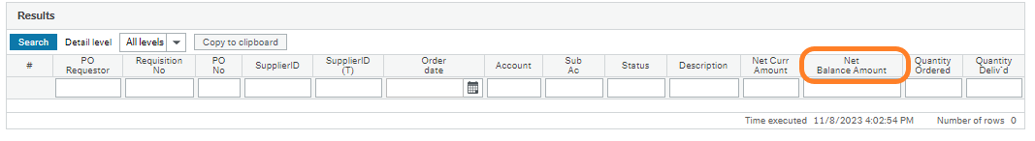
To view Paid/Closed Purchase Orders – Remove the ‘O’ for Open entry under the Statu field.
There are various selection criteria fields that can be used to limit your search. Ie PO Number
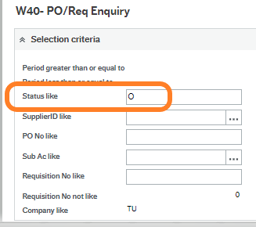

Transaction Listings
Report lists all Non-Pay Transactions (Paid items)
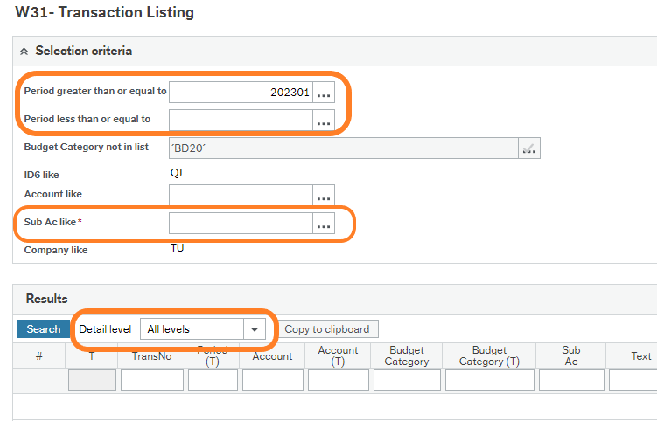

- Enter the Subacc (Dept/Project)
- The results are displayed by Budget Category, which can be expanded by clicking on + to the left of the line items or selecting all levels under detail level.
- Clicking on the transaction number will take you to the transaction details screen, which will display attached documentation ie Invoice.
- Report is currently set to run from Sept 2022 (Period=202301) – this entry field can be removed
- To search for a particular period ie Sept 2022 to August 2023 enter as follows

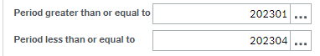
Refer to Agresso Period Month Set up below
Agresso Period/Month Set Up
Year
Month | 2021 | 2022 | 2023 | 2024
Jan | 202105 | 202205 | 202305 | 202405
Feb | 202106 | 202206 | 202306 | 202406
Mar | 202107 | 202207 | 202307 | 202407
Apr | 202108 | 202208 | 202308 | 202408
May | 202109 | 202209 | 202309 | 202409
Jun | 202110 | 202210 | 202310 | 202410
Jul | 202111 | 202211 | 202311 | 202411
Aug | 202112 | 202212 | 202312 | 202412
Sep | 202201 | 202301 | 202401 | 202501
Oct | 202202 | 202302 | 202402 | 202502
Nov | 202203 | 202303 | 202403 | 202503
Dec | 202204 | 202304 | 202404 | 202504

Invoices Paid
Search fields are available are Supplier ID and Order No.
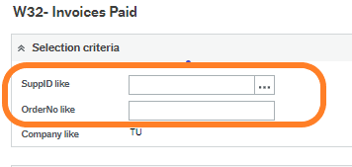
If clicking search does not return any information, the PO number has not been matched to an invoice and payment has not yet been processed.
If you have an invoice due for payment quoting a valid TUS PO number please forward to AccountsPayable@tus.ie
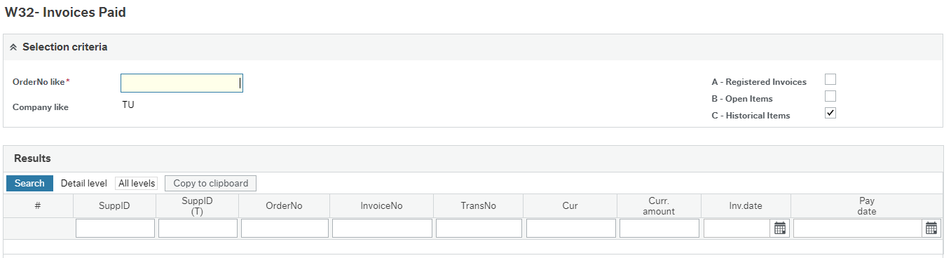

Supplier Look up

This report can be used to check Supplier details such as postal address and email address.
The Supplier ID can be entered and click search.
To look up a Supplier ID – Click on the 3 dots next to the Supplier name
Enter the name of the Supplier and include an Asterix before and after the name. *Name*
Select Search.
Select the Supplier from the list below and Click Search again to view the Supplier Details
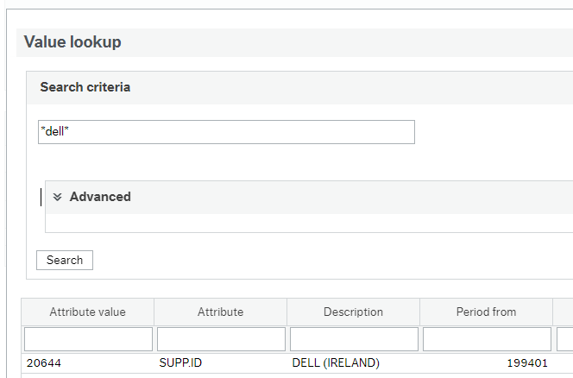

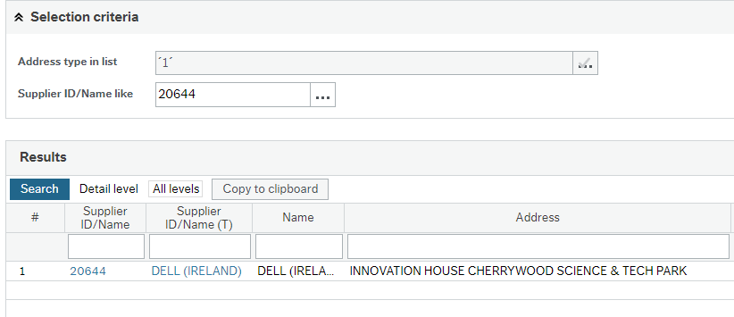

Additional Reports

There are some additional reports available in addition to those listed above,but are area specific.
If you wish to request access to specific reports or have any further queries in relation to the web reporting facility, please email AgressoSupport@tus.ie

Exporting Reports

You have the option to export the report results using the ‘Export’ button on the bottom of the screen. You can export in a number of different formats:

- Browser [.xlsx] – this will export the report results to excel in a specific browser format. Categories are summed up and can be expanded using the + on the left.
- Pivot [.xlsx] – this will export the report results to excel as a pivot table.
- Default [.xlsx] – this will export the report results to excel as plain data
- Default [.pdf] – this will export the report results to Adobe Acrobat in pdf format.

Queries
If you wish to request access to specific reports or have any further queries in relation to the web reporting facility, please email AgressoSupport@tus.ie

