AGRESSO GUIDE
GOODS RECEIVED NOTE (GRN)
When Goods are received a Goods Received Note (GRN) should be generated at the time of delivery to facilitate prompt payments to Suppliers.

To generate a GRN
- Enter the Order Number
- External Reference - Enter Delivery Docket/Receipt Number
Option 1
- Enter the Quantity Received for each item under the column Qty. received column
Receipting each item individually in this way is only required for part delivered orders
Option 2
- If all items on the Order have been received in full - Tick this Box to select all order lines
- Click Goods Received – doing this will mark each line as fully received.
- Additional Delivery information – Enter details of where delivered items are located ie Labs
- Click Save – You will be provided with a Good Receipt Number (not required to take note of)

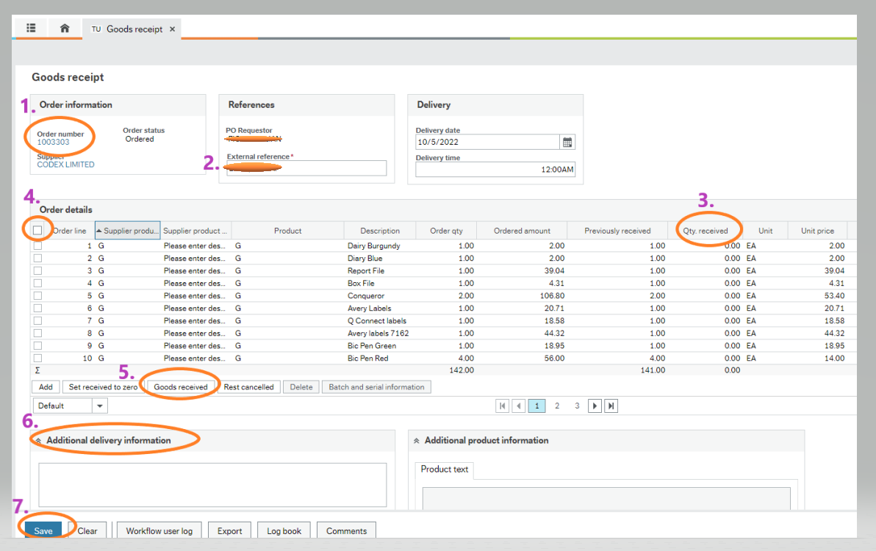

If an invoice is submitted to Accounts Payable requesting payment where a purchase order has not been confirmed as delivered by a GRN, you will be alerted through your tasks of a Missing GRN

To generate a GRN from a Task Alert
- Go to your Tasks in Agresso
- Select the item - Missing GRN – Trans No- Supplier Name
- Click on Goods receipt
- Complete the GRN as outlined in the Steps above
- Click on Task Complete

